DUVAL BRANCH OF WALNUT CREEK – PAVED TRAIL EROSION REPAIRS
2
4e
3e
1
Trail Repair Areas – 1, 2, 3, 4 - see description on following page
Repair procedure: Broom/brush out leaves from void. Place an initial layer of quickcrete over the entire bottom of void. Fill void with stone from creek to within 4-6” of trail level, adding quickcrete to fill voids. Top off with quickcrete to approx. ½ inch above adjacent trail level. Bevel edge with trowel. Note repairs less than 6” depth will made with quickcrete only (no rock backfill).
Evaluate local drainage for potential to allow drainage to pass over trail to creek at locations 2 and 3. Install 4” or 6” Schedule 40 PVC pipe for cross drainage or leave a “valley” flume across trail to allow water to pass.
Environmental precautions: Absolutely no concrete washout will be permitted on site! Strict adherence to “pack it in – pack it out” protocols. Work will be scheduled when dry weather is forecast. In the unlikely event of an unforecasted rainfall event, all tools and materials will be evacuated from site.

Estimated Quantities
Item | Description | Quantity | Units | Unit cost | Ext. cost
1 | Area 1 concrete [15 lf x 4’ width x 2’depth] x 0.4 void ratio = 48 c.f. use 80 lb bag (0.6 cf each) | 80 | ea | $3.23 | $258.40
2 | Area 2 concrete [multiple voids - 90 lf at 8’ width and 1.5’ depth] x .4 void ratio = 432 c.f. use 80 lb bag (0.6 cf each) | 720 | ea | $3.23 | $2325.60
3 | Area 3 concrete [multiple voids - 90 lf at 8’ width and 1.5’ depth] x .4 void ratio = 432 c.f. use 80 lb bag (0.6 cf each) | 720 | ea | $3.23 | $2325.60
4 | Area 4 concrete [10 lf x 2’ width x 0.5’ depth] = 10 c.f  use 80 lb bag (0.6 cf each) | 17 | ea | $3.23 | $54.91
5 | Mixing tubs | 2 | ea | $12.98 | $25.96
6 | Mixing hoes | 2 | ea | $15.97 | $31.94
7 | Vehicle rental, 4wd (for transporting concrete to site, including $290 delivery and return) | 1 | day | $531.00 | $531.00
8 | Vehicle rental, 4wd (for transporting concrete to site, including $290 delivery and return) | 2 | week | $748.00 | $1496
 | Total |  |  |  | $7049.41

Equipment rental (area 1 – 1 day, area 2 – 5 days, 3 – 5 days, add 3 for contingency)

1 – waterfall area – large washout at base of steep trail section. This is the highest priority repair due to 1) safety concerns with trail users (cyclists, runners, kids) accidentally falling into the void and 2) high energy gradient has potential to collapse the trail with chunks of concrete and underlying fill creating scour and sedimentation downstream. Note photo was taken approx. 5 days after significant rainfall. Repairs will be done during dry conditions.
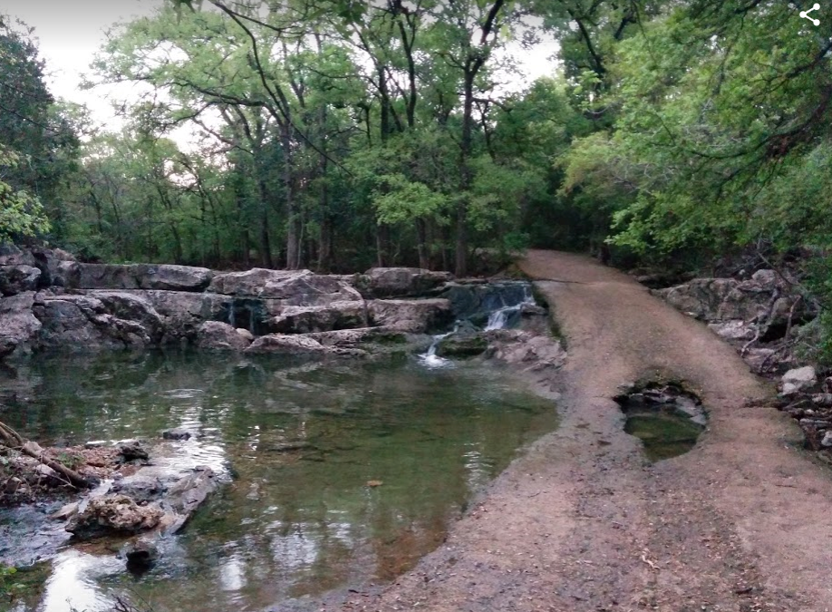

2 – Medium priority - irregular areas of trail loss due to ponding water during annual pool emptying and poor drainage across trail to creek. Consider adding a pvc pipe cross drain or leave a low area to allow water to pass to creek.
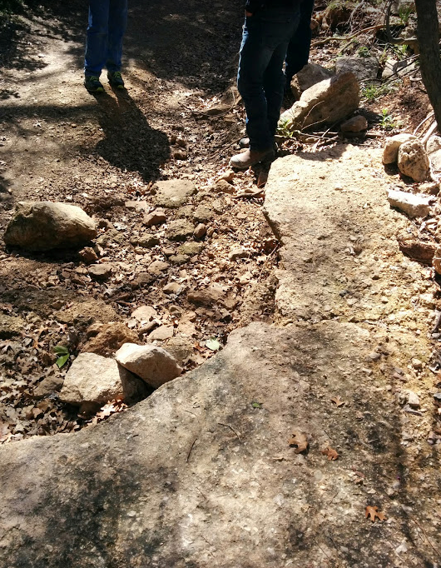

3 Medium priority – large area of trail loss due to water pooling between hill to right and creek (left)
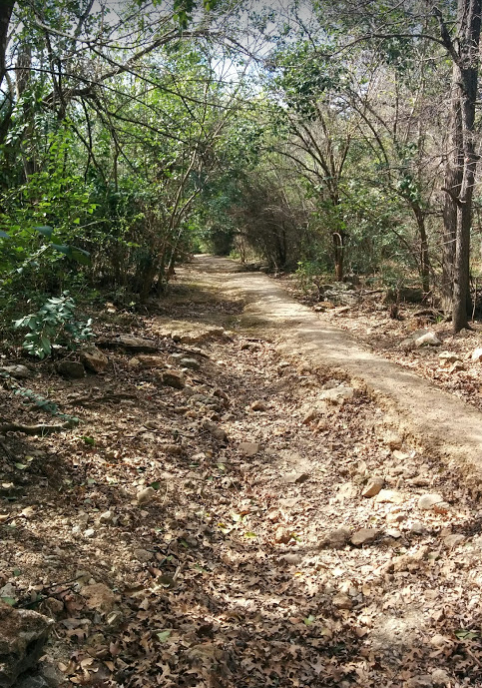

4 – low priority. Void between concrete and manhole ring left when manholes rehabilitated approx. 12 years ago.
