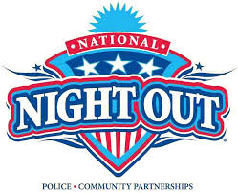

**Neighborhood Block Party**

**for National Night Out!**

**Tues. Oct 6th**

Time: ___________________

Place: ________________________

Bring a drink, a dish/dessert to share, and yourself,

and come and hang out with your neighbors!

Have questions or want to help contact us at:

Phone:_______________________ Email: __________________________________

Reminder: Please go to milwoodna.com and join the Neighborhood Email List

on the right column or email mnaboard@milwoodna.com

It's the easiest way for us to get out info on Crime & Safety & Other Milwood News.

