**Welcome to the Neighborhood Watch!**

**Your Block Captain is:**



**Contact info:**





**If you see a crime in progress, call 911**

**If you see suspicious activity, call 311**

**If you have info or tips, send them and**

**your street address to:**



**WARNING!**



**WE IMMEDIATELY REPORT**

**ALL SUSPICIOUS PERSONS**

**AND ACTIVITIES TO OUR**

**POLICE DEPARTMENT**

* Get to know your neighbors by name and be able to identify them and their vehicles.
* Call 911 if you ever suspect someone is in your area who should not be.
* Reduce high bushes and other foliage around your home in which people can lurk or hide.
* Give the appearance of someone being home when you are not. Lights on a timer. Car in the driveway.
* Have a neighbor check on your house frequently if you are out of town.
* Tell neighbors when you plan to have workmen coming, so people posing as workmen will be quickly ID'ed.
* Replace your exterior doors with 1 3/8 inches thick solid core doors with deadbolts. Lock all doors and windows when you are not home.
* Secure windows with 2 locking devices.
* Close garage doors or secure valuables in a car port whenever you are not right there.
* Invite a member of APD to do a safety audit on your property. You could save up to 15% on your home owner’s insurance premiums as well as have a safer home.
* Record serial numbers of electronics and keep an inventory of all valuables including jewelry, china, electronics, etc. The inventory (pictures, written list, etc.) should be kept in a fire-safe box somewhere away from your home.
* Engrave property that doesn’t have a serial number.
* Consider an alarm system or dog.
* Hide all valuables in your home or car. Someone should not be able to look into a window and see your valuables when you are not home. Store purses, laptops and cell phones out of sight.
* When out of town cancel all deliveries such as the newspaper, and have a neighbor check for handbills on the door. Arrange to have your lawn cared for if you are going to be away, and let only those who need to know when you are going out of town.
* Don’t hide keys under doormats or flowerpots or in similar places.
* Let a neighbor (especially your block captain) know how you can be reached in case of emergency.
* Report all crimes to the police immediately and post details to your neighborhood assoc. The more info. we all have, the better we can see patterns, prove to APD about the need for more patrols, and in general better deal with crime in our area.
* If you believe someone has broken into your house, leave immediately and call 911.
* If you are not already, become a member of your neighborhood assoc. The more community involvement and connectedness there is, the safer we all will be.

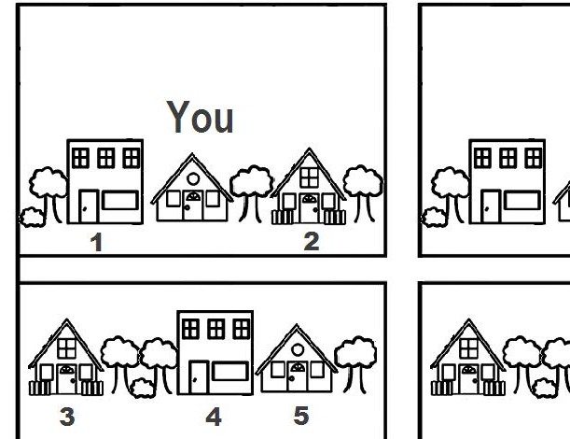

**Good Neighbors "Do the Five" -**

**One house on either side,**

**three across the street!**

My five are:

House #

______: Names:_________________________________________________________________

Emails:_________________________________________________________________

Phones:________________________________________________________________

______: Names:_________________________________________________________________

Emails:_________________________________________________________________

Phones:________________________________________________________________

______: Names:_________________________________________________________________

Emails:_________________________________________________________________

Phones:________________________________________________________________

______: Names:_________________________________________________________________

Emails:_________________________________________________________________

Phones:________________________________________________________________

______: Names:_________________________________________________________________

Emails:_________________________________________________________________

Phones:________________________________________________________________